# Customer Meeting

Customer meeting date to demo this iteration.

Our next meeting with client is on 15-March-2022 at 4:45 pm

## User Stories Implemented

User stories implemented in this iteration.

User stories we implemented in this iteration are:

1. Host Login user story

**Please Note:** We intentionally chose to implement host login as the only user story for this iteration. We recognize that this is significantly less than ¼ of the user stories for our project. We made this decision because:

1. For the first week of the iteration we were trying to get approval from the professor on using React for frontend and Django for backend.
2. A lot of the initial work went into project deployment setup and configuration.

During the following sprints we plan to do a ⅓ of the remaining user stories for each iteration.

# Tasks Accomplished.

Tasks accomplished in iteration1:

1. Finalizing the requirements
2. Deciding on technologies and frameworks to use
3. Setting up the backend, frontend and establishing their communication
4. Created BDDs and TDDs for backend apis
5. Developed apis for user login
6. Developed apis for user signup
7. Created BDDs and TDDs for frontend
8. Developed frontend for user login and signup
9. Designed database models

# Design diagram for this iteration. (DB, Model design)

<https://lucid.app/lucidchart/901b0e43-df07-48df-bdc9-1ae8d9c21f7c/edit?invitationId=inv_9b5c53ff-65f9-4977-80c7-e0b6e4731c41&page=J960fNmy6zCK#>

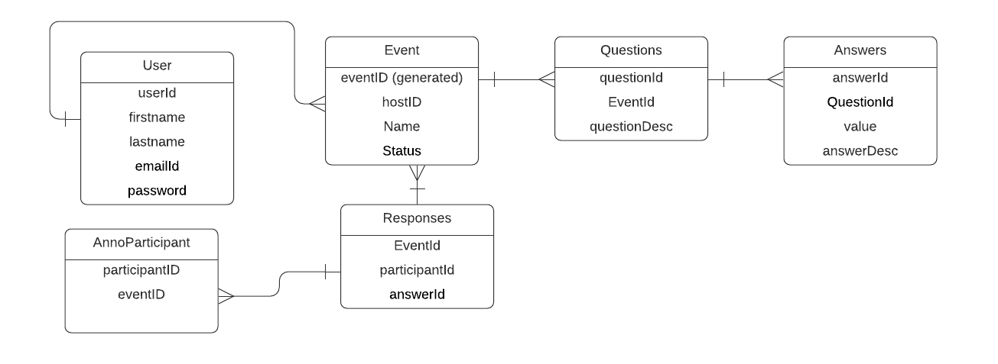

# TESTS

## Backend

**Results:** BDDs test results for backend apis

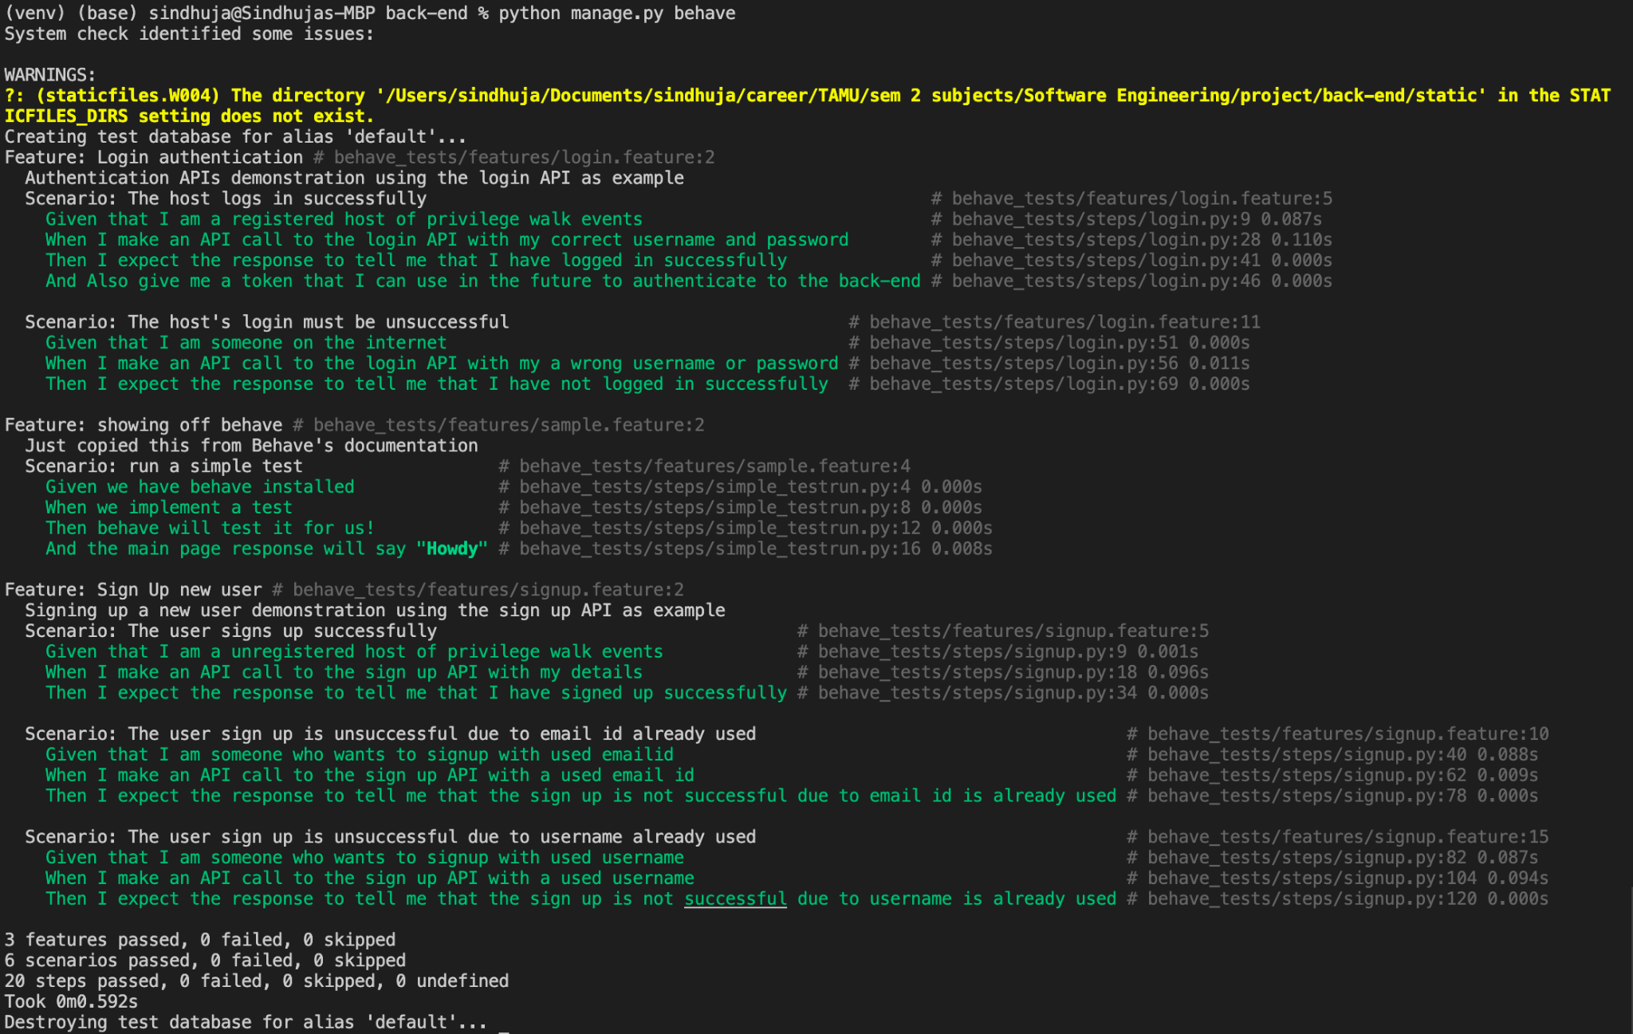

Backend TDDs

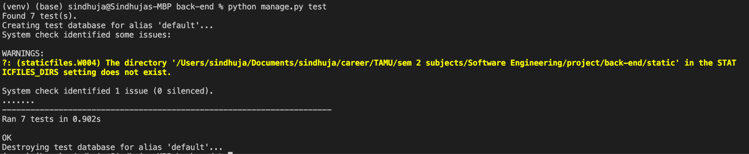

**Coverage:** Backend tests with 100% coverage.

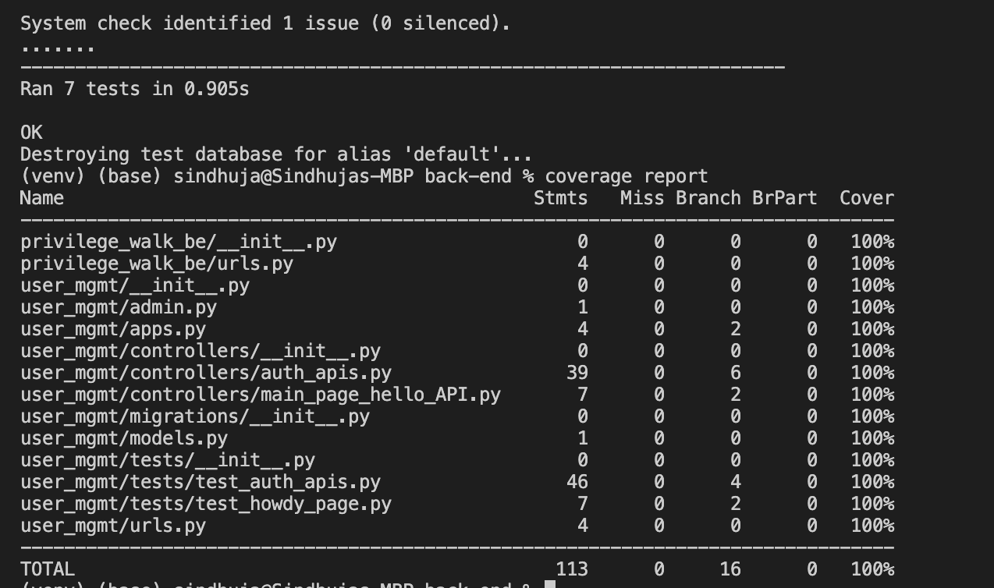

The instructions to get coverage report is mentioned in ReadMe of repo: <https://github.com/Privilege-walk/back-end.git>

Steps to Run backend tests:

1. Git clone the backend repo
   1. git clone https://github.com/Privilege-walk/back-end.git
2. Install requirements
   1. Look at the Running instructions mentioned in ReadMe at <https://github.com/Privilege-walk/back-end.git>
   2. Once you create and activate virtualenv install the requirements using command
      1. pip3 install -r requirements.txt
3. Run BDDs
   1. We used ‘behave’ to create BDDs for the features and scenarios as we are developing backend in Django
   2. The BDDs can be run at once by using below command:
      1. python manage.py behave
4. Run TDDs
   1. All the TDDs for all apis scenarios can be tested using the command
      1. python manage.py test

For more detailed explanation on instructions to run tests for backend are mentioned in ReadMe of the repo: <https://github.com/Privilege-walk/back-end.git>

## FRONTEND

**TDDs:**

**Coverage**: TDDs frontend test coverage is 100%

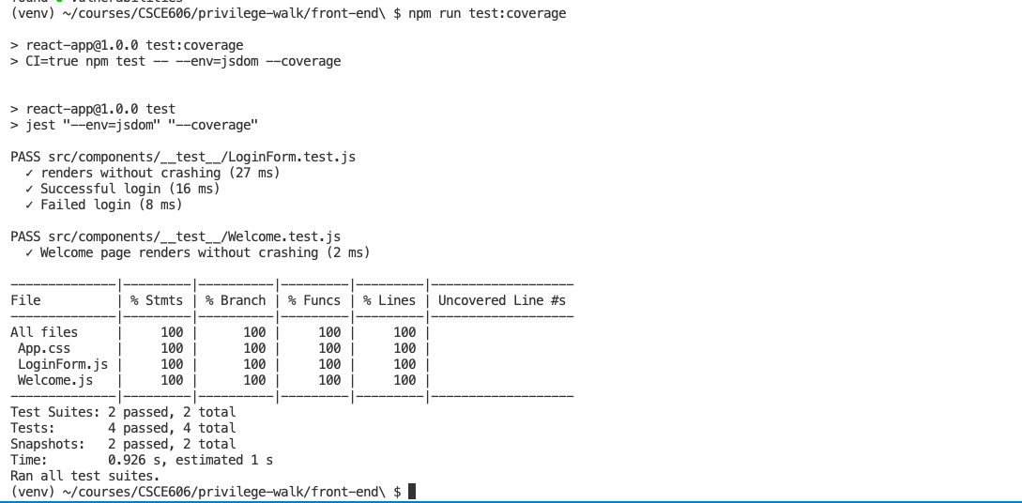

**Results:** for TDDs

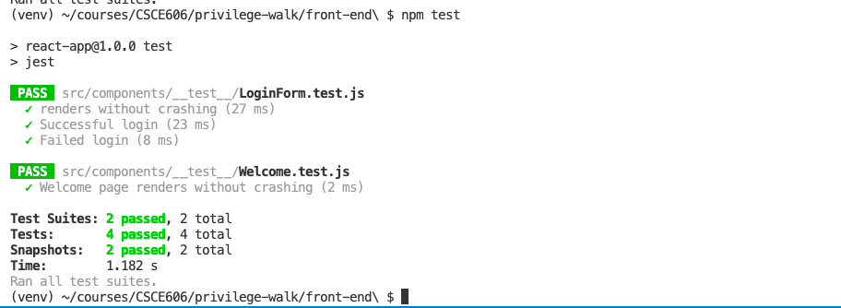

**BDDs**

**Results:**

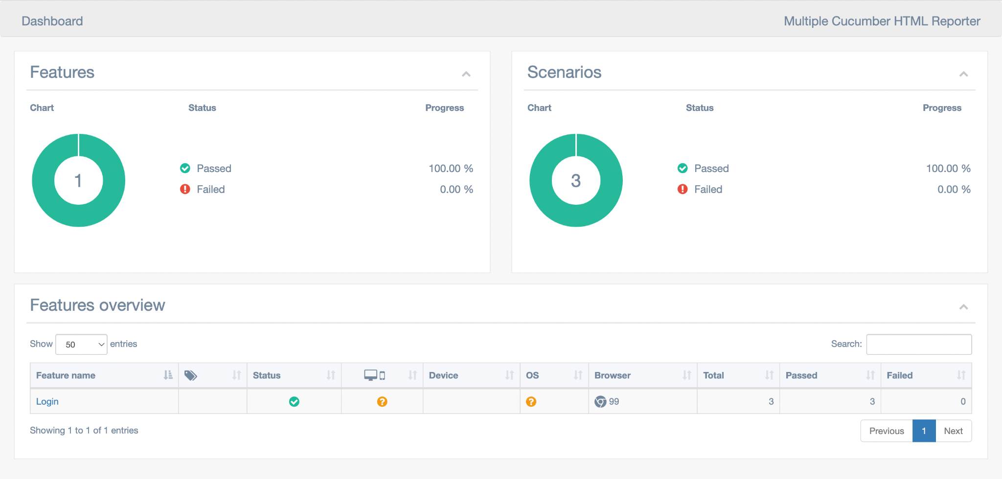

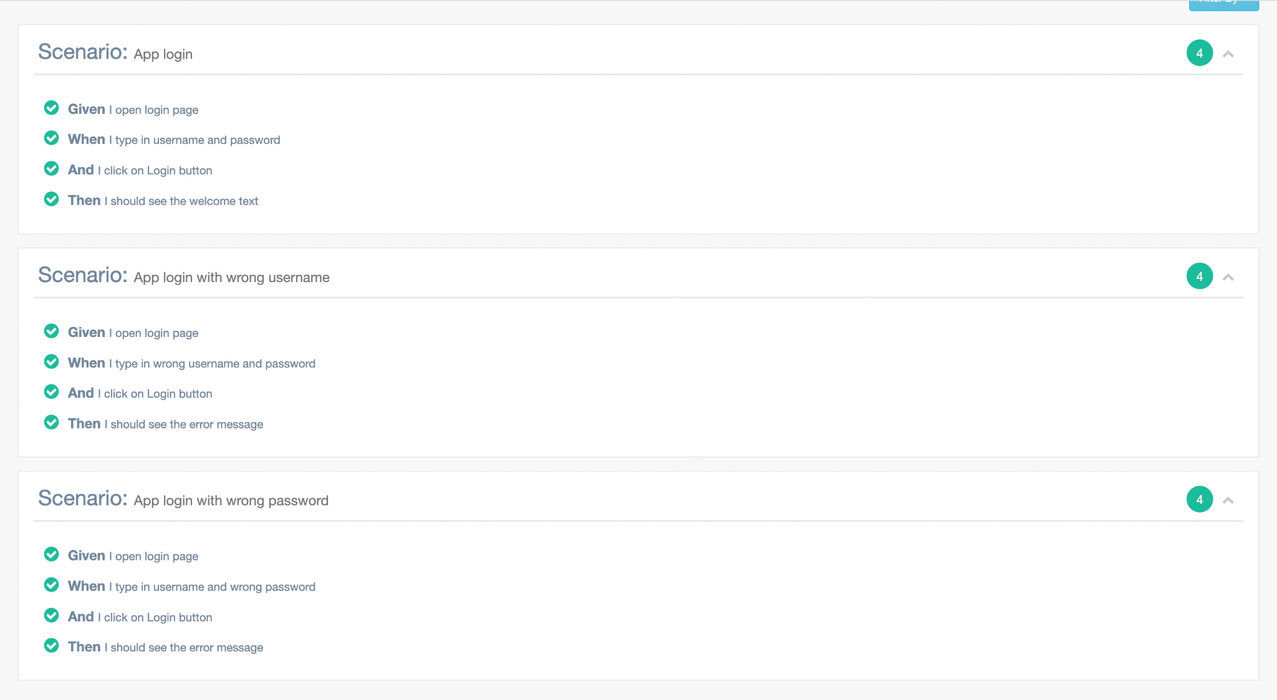

**STEPS**

Steps to Run frontend tests:

1. Clone the repository and switch to the root of the repository.
   1. git clone <https://github.com/Privilege-walk/front-end.git>
   2. cd front-end
2. Install npm packages.
   1. npm install
3. RUN TDDs.
   1. npm run test
4. RUN BDDs
   1. Make sure frontend is up by running.
      1. npm start
   2. Make sure the back-end is running by (I’m assuming you’ve cloned the backend repository and installed requirements. See steps 1 and 2 below in “Steps to Run backend tests”):
      1. python manage.py runserver
   3. Run BDD tests by running.
      1. npm run test-bdd

For more detailed steps please checkout README for frontend: https://github.com/Privilege-walk/front-end/blob/main/README.md

# LINKS

Pivotal Tracker: <https://www.pivotaltracker.com/n/projects/2556087>

GitHub Repo Backend: <https://github.com/Privilege-walk/back-end>

GitHub Repo Frontend: <https://github.com/Privilege-walk/front-end>  
GitHub Repo Project: <https://github.com/Privilege-walk/privilege-walk>  
Heroku Deployment backend: <https://privilegewalkbe.herokuapp.com/>  
Heroku Deployment project: <https://privilegewalk.herokuapp.com/>

Code Climate Frontend: <https://codeclimate.com/github/Privilege-walk/front-end>

Code Climate Backend: <https://codeclimate.com/github/Privilege-walk/back-end>